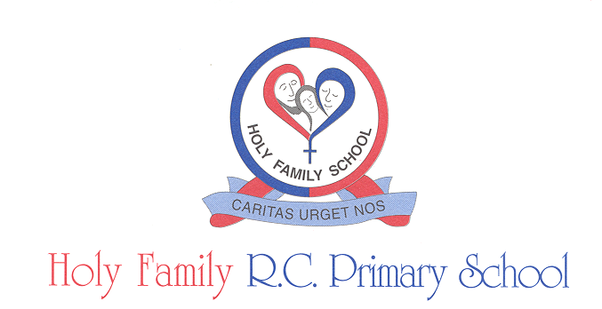

Head Teacher: Mrs J Westray

**Holy Family Weekly Newsletter 12.11.2021**

25

***We follow in Jesus’ footsteps***

Holy Family Church

Fr Peter Draper

Tel: 01772 725193



Tel: 01772 727471

Bursar@holy-family.lancs.sch.uk

**Remembrance prayer for children**

We remember those who stood for love and truth,

And thank you for the sacrifice they made for me and you.

Thank you that we can now enjoy peace and learn to love not fight,

Thank you that we can now sing and play, and not be scared or hide.

We pray for other countries where children live in fear,

And there is war and fighting and many are in tears.

Please help to make things better, and bring some peace to them. Protect all those who try and help to make friends again.

Amen.  
  




**Star Awards**

YR – Scarlett

Y1 – Adam

Y2 –

Y3 –

Y4 – Daria

Y5 – Harry

Y6 – Maks



**Remembrance Day Respect**

As well as the stunning display at the front of school, everyone wearing poppies to support The Royal British Legion, taking part in very meaningful worships and reflections in classes, we also observed two minutes silence on the playgrounds. This was very moving – the children were completely still and silent, including our fantastic Reception and Nursery children!

Our fantastic Year Six children enabled us to think about all of those who were so brave and put themselves before other people – many thanks to the pupils, Mrs Wilson and Miss Oates.

Our book of Remembrance is circulating around school but if parents would like to add to it, please do let Mrs Anforth in the office know. Many thanks to parents who have supported The Royal British Legion this year.



**Good Samaritan Awards**

YR – Samuel

Y1 – Lilly

Y2 -

Y3 –

Y4 – Marta

Y5 – Maya

Y6 – Jack

**Dates for your Diary**

**Friday 22October** – school closes for half term 3.10pm

**Monday 1 November** – School reopens

**Friday 19 November** – Odd sock day for anti-bullying

**Friday 26 November** – Staff Inset day

**Wednesday 15 December** – Christmas lunch day – own clothes

**Thursday 16 December** – School closes for Christmas 1.00pm

**After School Club**

If you wish your child to attend After School Club you must pre-book through SCOPAY only.

**Christmas lunch day is 15th December**

If you wish your child to have a Christmas lunch please book via SCOPAY by Tuesday 16th November. We will be unable to take any additional bookings beyond this date.

**Coronavirus CHANGES TO NATIONAL SELF-ISOLATION GUIDANCE**

From 16 August, the Government has said that people aged under 18 years and 6 months or who are fully vaccinated will no longer be legally required to isolate if they are a close contact of someone with COVID-19. Instead, such people will be advised (but not legally required) to get a PCR test unless they have had a positive PCR test in the previous 90 days.

Regardless of age or vaccination status, anyone who develops any of the three main COVID-19 symptoms (see below) must get a PCR test as soon as possible and isolate until the result is available. People who get a positive PCR test must continue to isolate as usual.

The main symptoms of COVID-19 are:

* new continuous cough and/or

fever (temperature of 37.8°C or higher)

loss of or change in, normal sense of taste or smell (anosmia)

**PLEASE ADVISE SCHOOL IF YOUR CHILD HAS HAD A POSITIVE PCR TEST.**

**PLEASE DO CONTACT SCHOOL IF YOU WOULD LIKE ANY ADVICE.**

**‘One kind word’ - Anti-Bullying Week 2021 – Odd sock day on Friday 19th November**

Anti-Bullying Week is coordinated In England by the Anti-Bullying Alliance and takes place from 15 to 19 November 2021. On Friday 19th we will all be wearing odd socks to support this event. Kindness is more important today than it has ever been. The isolation of the last year has underlined how little acts of consideration and charity can break down barriers and brighten the lives of the people around us. This is one of the reasons, that **‘One Kind Word’** has been chosen as the theme of Anti-Bullying Week taking place from **15 to 19 of November 2021. One Kind Word** can be a turning point. It can change someone’s perspective. It can change their day. It can change the course of a conversation and break the cycle of bullying. At Holy Family school we know that one kind word leads to another. Kindness fuels kindness – “we follow in Jesus’ footsteps.” We can all play a part in a chain reaction that powers positivity. We believe this upbeat message will resonate with the children who know all too well how unkind words can hurt and undermine them.