DENOMINATIONAL INSPECTION

REPORT (Section 48)

on

THE CATHOLIC LIFE OF THE SCHOOL
AND
RELIGIOUS EDUCATION

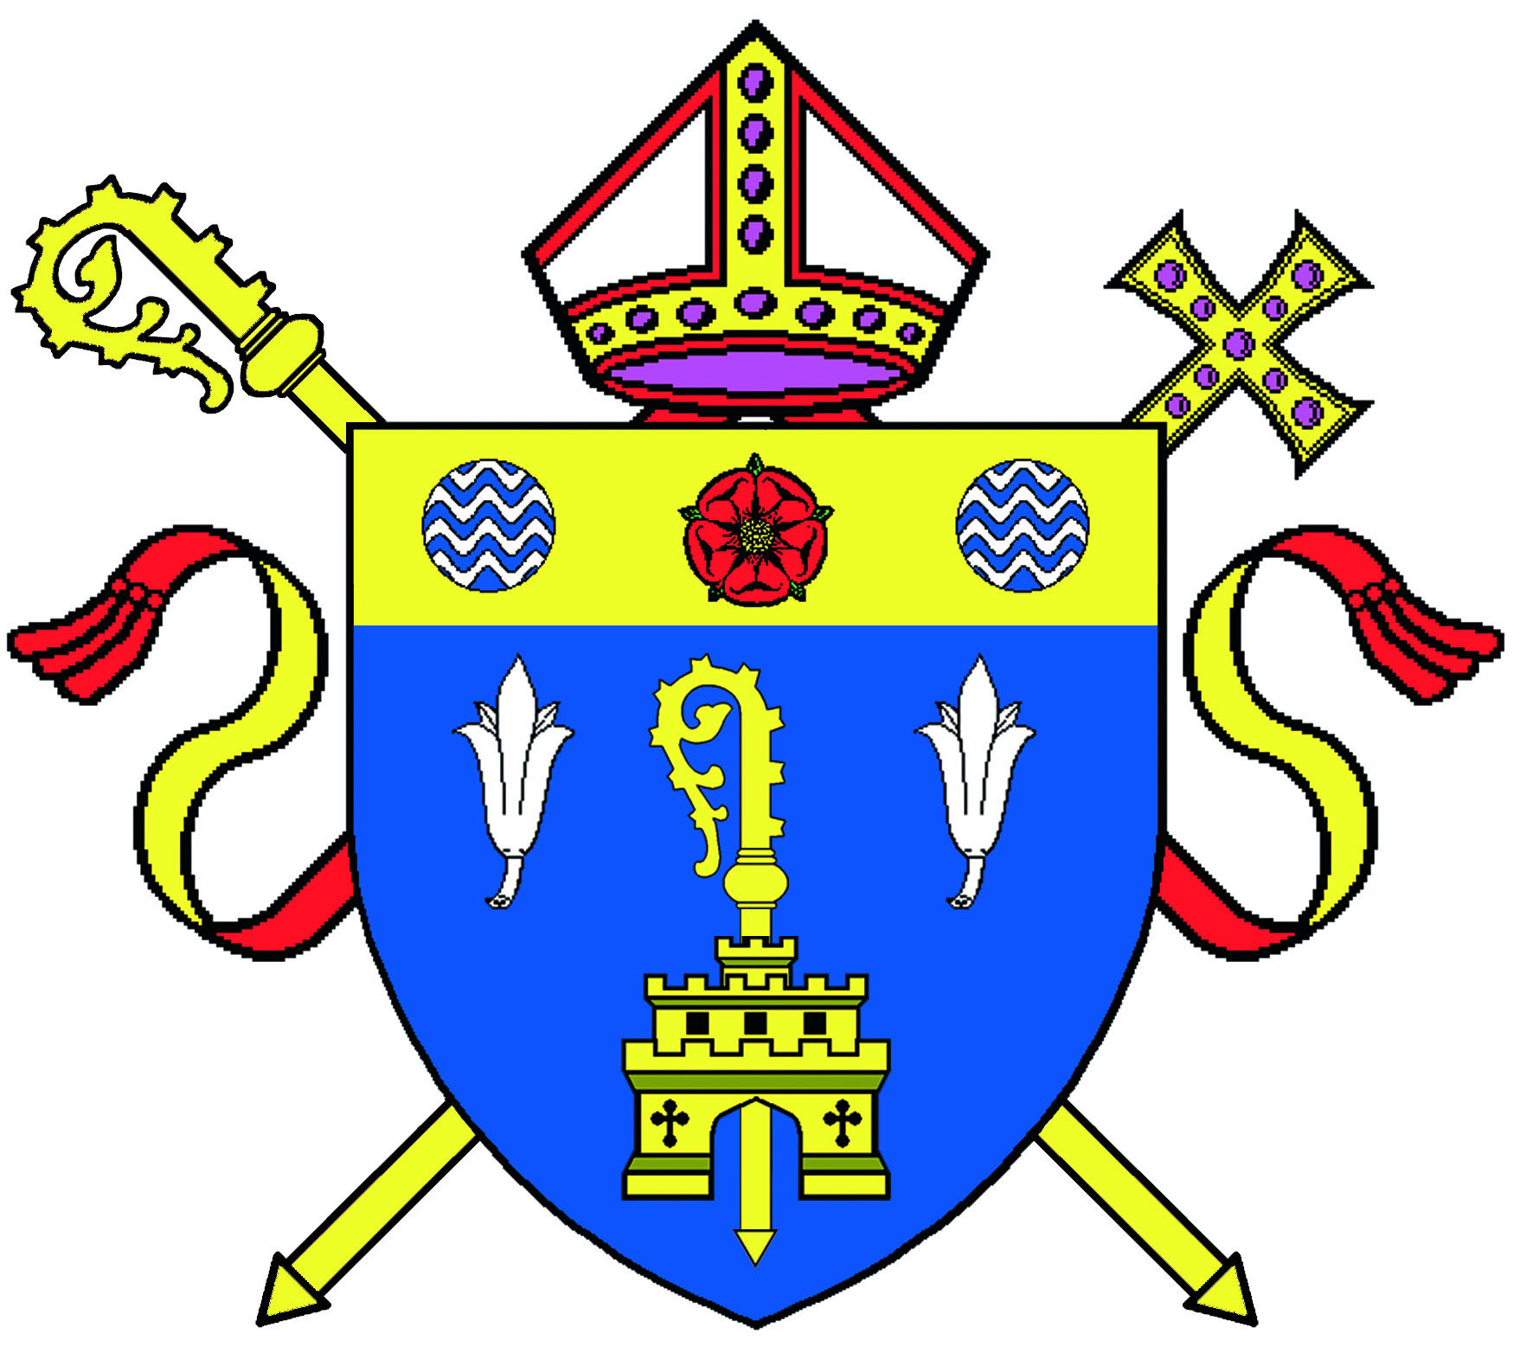

School: Holy Family Catholic Primary School

Address: 59 Whitby Avenue

Ingol

Preston

PR2 3YP

Telephone Number: 01772 727471

Email address: head@holy-family.lancs.sch.uk

School URN: 119611

Headteacher: Mr Raymond Sudlow

Chair of Governors: Mr Alan Gaskell

Section 48 Inspector: Mrs Adrienne Delaney

Date of Inspection: 2nd December 2011

The inspection report is produced for the Rt. Reverend Michael Campbell O.S.A., the Bishop of Lancaster (c.f. Code Canon Law, 804, 806), and for the Governing Body of the school (Education Act 2005, Section 48). The inspection reviews, evaluates and plans further improvements in the school’s witness to the Catholic faith and Curriculum Religious Education. This process begins with the school’s own self-evaluation.

The inspection schedule follows criteria set by the National Board of Advisers and Inspectors.

INFORMATION ABOUT THE SCHOOL

Holy Family Catholic Primary School is an average sized school situated in Preston, Lancashire, in an area outside the city centre. The majority of pupils live in the local area.

Most pupils are of white British heritage. The number of pupils with English as an additional language (EAL) is very low when compared to the national average. It is an area of high deprivation with an above average number of pupils eligible for free school meals (FSM).

FACTUAL INFORMATION

Pupil Catchment:
Number of pupils on roll: 149
Planned Admission Number of Pupils: 25
Percentage of pupils baptised Catholics: 65%
Percentage of pupils from other Christian denominations: 32%
Percentage of pupils from other faith backgrounds: 1%
Percentage of pupils with no religious affiliation: 1.5%
Percentage of pupils from ethnic groups: 6%
Percentage of pupils with special needs: 13%

Staffing
Full-time teachers: 6
Part-time teachers: 1
Percentage of Catholic teachers: 71%
Percentage of teachers with CCRS: 62%

Percentage of learning time given to RE:
R 10% Yr 4 10%
Yr 1 10% Yr 5 10%
Yr 2 10% Yr 6 10%
Yr 3 10%

Parish served by the school:

1. Ingol Holy Family

2. St Andrews

Overall Effectiveness | 2

Capacity for sustained improvement | 1

MAIN FINDINGS

Holy Family is a good school. It is well led by a committed headteacher and its positive Catholic ethos results in well- behaved, polite pupils. Pupils’ spiritual and moral development is given high priority. The vision that the headteacher has for the school is shared by the governors and all the staff. Good relationships are evident and these result in a harmonious and inclusive community. All areas for improvement since the last inspection have now been acted upon and good procedures are in place. The implementation of these procedures has demonstrated significant impact on progress and attainment. The school’s capacity for sustained improvement is outstanding.

Children are happy to attend Holy Family and they demonstrate pride in their school, which results in positive attitudes to learning. Progress across the school is good with improvement evident during the past year. However, RE attainment, overall, is slightly below average with on-entry assessments well below the expected standard in RE. Pupils are well supported in their learning and additional support is generally well deployed. The use of targeted support ensures that pupils, particularly those with special educational needs, are progressing well. More able pupils are not always being sufficiently challenged. The school offers pupils opportunities to contribute to the Catholic life of the school. Pupils show interest in the spiritual and moral values of others and respond in a caring manner to those in need. They are showing developing independence in preparing prayer and acts of worship.

The school provides a good Catholic education for pupils. Teaching is good and there is evidence of this in lessons. Lessons show good differentiation. Marking shows positive comments and advice for pupils as to how to improve their work. Assessment and monitoring systems are in place and are beginning to have a positive impact on individual pupil progress. Parents and carers are kept informed as to learning and progress. The Religious Education curriculum is good with some additional resources being used to enhance it. The quality of Collective Worship is good with children now taking ownership for preparation and delivery.

The headteacher, who is also the Religious Education leader, together with an effective senior leadership team, has a clear vision for the subject and for the Catholic life of Holy Family Catholic School. He is committed to improving outcomes for pupils. Teaching and learning are being monitored well and tracking systems are in place to improve outcomes. The impact of these is analysed, and priorities are set out in the School Development Plan. The quality of self evaluation is good. However, the quality of the self evaluation document does not always reflect the impact of the success of measures taken. The headteacher and the well established able senior leadership team, through analysis and evaluation, are able to identify the training needs for the whole staff. Their approach to professional development has been pivotal to good teaching and learning. Governors are committed to discharging their responsibilities well and are eager both to challenge and to support the school. Partnerships with other providers and organisations have been established and are promoting Catholic learning. Pupils are developing the sense of belonging to a wider community and the understanding of the common good.

Capacity for improvement

The school’s capacity for sustained improvement is outstanding. Leaders and managers have high expectations of staff and pupils and are working together to continue making positive changes. The Catholic mission underpins all school life and the headteacher, together with his able deputy, demonstrate a clear understanding of areas for development. These areas have been prioritised and the impact on standards is evident.

What the school needs to do to improve further

Continue to raise standards in Religious Education by:
- Ensuring that more able pupils are planned for so that they are better challenged in RE.
- Improve the quality of the self evaluation document by demonstrating accurately the impact of measures taken.

PUPILS

How good outcomes are for pupils, taking particular account of variations between different groups | 2

The majority of pupils enjoy Religious Education and have positive attitudes towards their learning. As one child put it during the inspection, “I like learning all RE”.

Assessment data and pupil tracking are evidence of continuous improvement in trends over time. The headteacher, new deputy headteacher and staff have implemented plans that demonstrate this improvement. Data shows that, from low starting points, pupils make good progress through the Foundation Stage and through key stages one and two. Evidence also shows that pupils’ progress has been improving since the last inspection. Pupils have a developing sense of religious literacy and their knowledge and progress are good. Pupils in receipt of free school meals make good progress, as do those with special educational needs and disabilities. Pupils who are more able are not consistently given challenging tasks. Parents’ replies to the questionnaire show that they are satisfied with their children’s progress in RE. Pupils who have Special Education Needs and English as an Additional Language are well supported by the use of identified interventions, delivered by skilled support staff. Their progress is good, but attainment is still low, with only a few children reaching expected standard at the end of Key Stage 2. The school has addressed this issue and current assessment data projections for the end of this academic year show that the majority of pupils will reach the expected standard by the end of Key Stage 2.
Pupils are making a good contribution to the Catholic life of the school and derive benefit from it. The older pupils willingly take on extra responsibilities and some pupils in the school participate in activities within the class, the school and the local community. Older pupils interviewed spoke with pride of their involvement in the school council. “We raise funds for charities through selling toast” was one proud claim. They show interest in the religious life of others and can express their own spiritual beliefs. This was illustrated in discussions with pupils during the inspection when the children spoke knowledgeably about several other world faiths. Pupils understand the main celebrations of the liturgical year and celebrate them within their parish community. They show a sense of consideration and justice, which is demonstrated by the good relationships shared within the whole school, parish, local and global community. In interviews they spoke of the commandments “helping us to understand how to live now” and how the “parables teach us important lessons and messages about justice and charity”.

Pupils respond to, and participate in, Collective Worship very well. They behave reverently and are eager to be active in planning prayer and Acts of Collective Worship; expertise and confidence are growing in this area. Pupils sing joyfully and can engage in silent reflection. They understand religious seasons and show respect for religious artefacts. Foundation Stage pupils can talk about the Advent Wreath candles and they pray with reverence. In the Key Stage 1 worship observed, pupils maintained prayerful silence before volunteering thoughtful answers that were posed by their confident peers. In the Key Stage 2 worship observed, the pupils led their peers in discussion about preparation for the birth of Jesus. They are able to use ICT to complement this activity. Collective Worship contributes well to the moral and spiritual growth of pupils.

LEADERS AND MANAGERS

How effective leaders and managers are in developing the Catholic life of the School | 2

The school’s leaders and managers promote the Catholic life of the school well. The headteacher, his deputy and staff give the Catholic mission of the school priority and pupils’ moral and spiritual development is at the heart of school improvement.

Monitoring and evaluation of the provision for RE are good and are a key strength of the school. The headteacher, together with his deputy and senior staff, have put plans in place to ensure that outcomes have a positive impact on teaching, learning, progress and standards. He has high expectations of staff and pupils in school. Plans are aimed at continuous development and improving results. Leaders work closely with the parish priest and the religious sister assigned to the parish, to promote the Catholic life of the school.

Governors challenge and support the school effectively; many of them are regular visitors to the school. They have accessed training and are well informed of RE. The chair of governors and chair of curriculum have been active in the planning for continuous improvement and were involved in setting the priorities in the development plan. The parish priest is a regular visitor to the school, supporting staff, parents and pupils. The parish religious sister, who is also a governor, plays a pivotal role in religious and pastoral support for the pupils, staff and families. Governors fully uphold their statutory and canonical duties; they carry out their responsibilities and duties as both challengers and supporters of the headteacher. Training for governors and leadership within the school has enabled this to happen.

Leaders and managers have developed effective partnerships with other providers and services to promote Catholic learning and pupil well-being. This has led to them being instrumental in setting up a range of partnerships with these providers, organisations and services. Holy Family works well with other schools, the parish and local community, to provide good learning opportunities and to motivate pupils.

The headteacher and his leadership team have been instrumental in setting up ambitious links with parents, parish, local schools, schools in other areas and schools globally. This wide range of partnerships is enabling pupils to enjoy and to achieve well at Holy Family.

PROVISION

How effective the provision is for Catholic Education | 2

The quality of teaching and learning in Religious Education is good. In lessons observed, effective questioning techniques were employed, clear explanations were given and sound use made of resources, including ICT, ensuring that pupils make good progress. Teachers’ subject knowledge is good and there are plans for continued professional development based on findings drawn from rigorous monitoring. Pupils with identified needs have different tasks to meet these needs, but more able pupils are not always given challenging tasks.

Assessment and monitoring procedures are good. Tracking progress in RE has become an integral part of the school’s monitoring system and contributes to effective target setting.

All staff have a growing understanding of how to effect progress for pupils. Regular assessment ensures that pupils know how well they are doing. The quality of marking is good and informs next steps in learning. Oral and written feedback is provided so that pupils know what to do in order to improve their work. Pupils questioned during inspection knew their targets and could state what they needed to do in order to improve.

The school provides a good Religious Education curriculum that is structured around the scheme ‘The Way the Truth and the Life’. Relevant strategies are employed to ensure that pupils’ learning needs are met. Long and short term planning is being monitored to ensure that pupils make good progress. Visits and visitors have a positive impact on learning and enrich the curriculum. Members of the parish community and other faith communities share activities and visit the school for celebrations. The school has made ambitious links that encompass local faith communities, other faith communities and school communities locally and internationally. The spiritual and moral development of pupils is enriched by the opportunities offered. The curriculum is meeting the statutory requirements of the Bishops’ Conference.

The quality of Collective Worship in the school is good and given a high priority. It ensures that the spiritual needs of the pupils are well met. It is inclusive and well planned and monitored so that all pupils can participate fully in it. There is evidence of pupils’ development in the preparation and delivery of this worship. The key Catholic liturgical celebrations are celebrated well. Prayer is central to the life of the school and formal and informal opportunities for prayer are offered. Acts of Collective Worship have a significant impact on pupils, parents and the parish. They are public demonstrations of the ethos of the school.
SUMMARY OF INSPECTION JUDGEMENTS

Key for inspection grades:
Grade 1 Outstanding Grade 2 Good Grade 3 Satisfactory Grade 4 Unsatisfactory

Overall effectiveness | 2
The school’s capacity for sustained improvement | 1
PUPILS How good outcomes are for pupils, taking particular account of variations between different groups | 2
- how well do pupils achieve and enjoy their learning in Religious Education? | 2
- the quality of pupils’ learning and their progress | 2
- the quality of learning for pupils with particular learning needs and/or disabilities and their progress | 2
- pupils’ attainment in RE | 3
- to what extent do pupils contribute to and benefit from the Catholic life of the school? | 2
- how well do pupils respond to and participate in the school’s Collective Worship? | 2
LEADERS AND MANAGERS How effective are leaders and managers in developing the Catholic life of the School? | 2
- how well leaders and managers promote, monitor and evaluate the provision for the Catholic life of the school and plan improvement to outcomes for pupils? | 2
- how well leaders and managers monitor and evaluate the provision for RE and plan for improvement to outcomes for pupils? | 2
- the extent to which the governing body provides effective challenge and support for the Catholic dimension of the school so that weaknesses are tackled decisively and statutory and canonical responsibilities met? | 2
- how well leaders and managers develop partnerships with other providers, organisations and services in order to promote Catholic learning and well being? | 2
- how effectively leaders and managers promote Community Cohesion? | 1
PROVISION How effective is the provision for Catholic Education? | 2
- the quality of teaching and purposeful learning in RE | 2
- the effectiveness of assessment and academic guidance in Religious Education? | 2
- the extent to which Religious Education curriculum meets pupils’ needs? | 2
- the quality of Collective Worship provided by the school? | 2

